Practical 4
- Notepad: 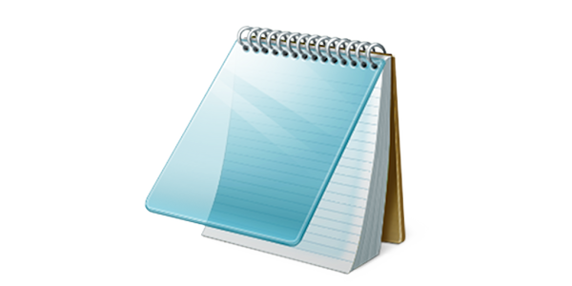Notepad is a simple, pre-installed text editor in Windows operating systems. It allows users to create, open, and edit plain text files, like notes, code snippets, and simple web pages (HTML). It's a lightweight program with basic text editing features and minimal formatting options.

Its UI looks like this:
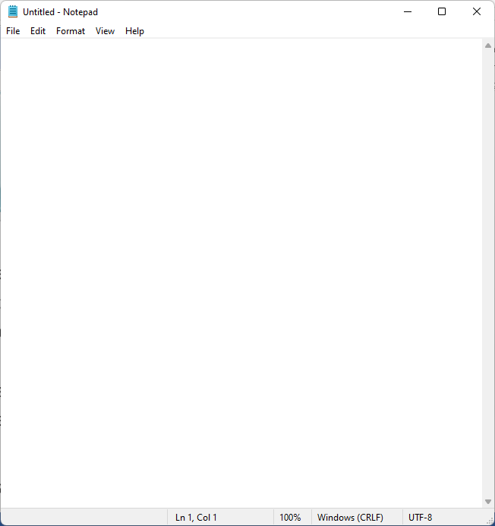

- WordPad:
WordPad is a basic word processor included with Microsoft Windows. It allows users to create, edit, and format text documents, offering more features than a simple text editor like Notepad, but fewer than more advanced word processors like Microsoft Word. WordPad can handle basic formatting like font styles, sizes, and colors, as well as paragraph alignment.
Its UI looks like this:
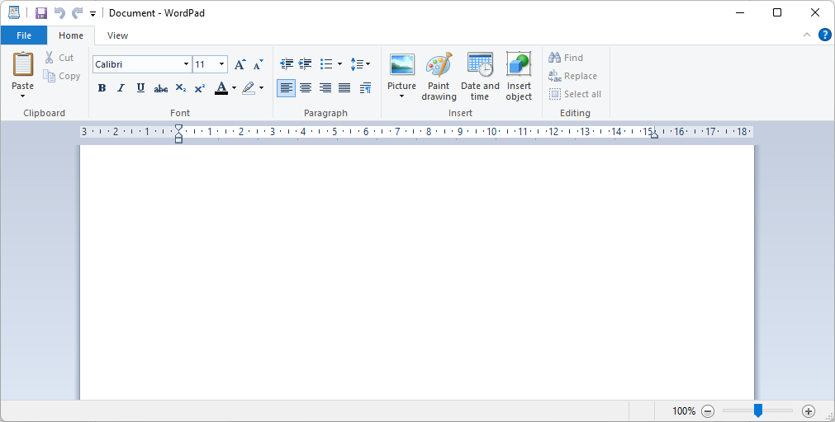

- Paint:
Microsoft Paint, commonly known as MS Paint or simply Paint, is a basic graphics/painting program included with all versions of Microsoft Windows operating systems. It is a raster graphics editor that allows users to create and edit images digitally.
This is its icon:
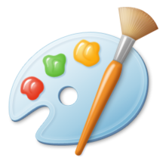
Its UI looks like this:
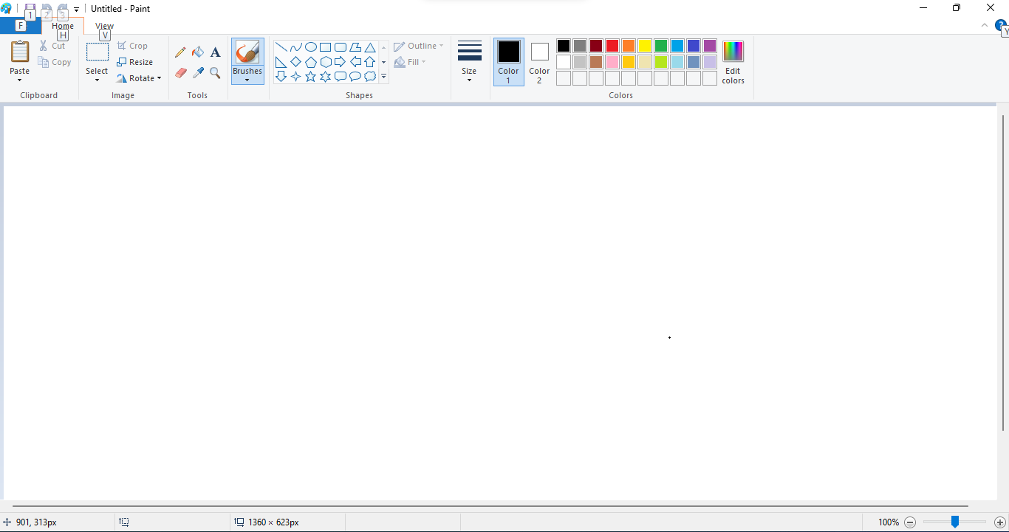

- Taskbar:
A taskbar is a visual element in a computer's operating system, typically a long horizontal bar on the bottom of the screen, which serves as a central hub for managing open applications and providing quick access to essential features.
It looks like this:
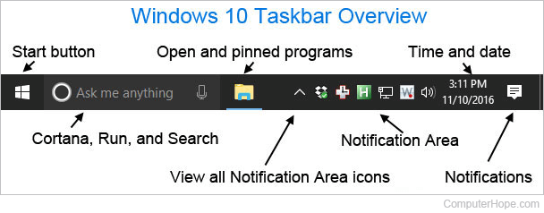
- Adjusting the display resolution:
To change the display resolution on a computer, navigate to the display settings through your operating system (e.g., Windows settings) and then select the desired resolution from the provided options. The resolution determines the number of pixels displayed on your screen, affecting the sharpness and size of content. To change the display resolution of a computer, follow these steps:
1. Access Display Settings:
Right-click on the desktop and select "Display settings" or search for "Display settings" in the Start menu.
2. Select the Monitor:
If you have multiple monitors, choose the one you want to adjust.
3. Choose Resolution:
Locate the "Display resolution" or similar setting and select the desired resolution from the dropdown menu.
4. Apply Changes:
Click "Apply" or "Keep changes" to save the new resolution. You may have a limited time to confirm the changes.

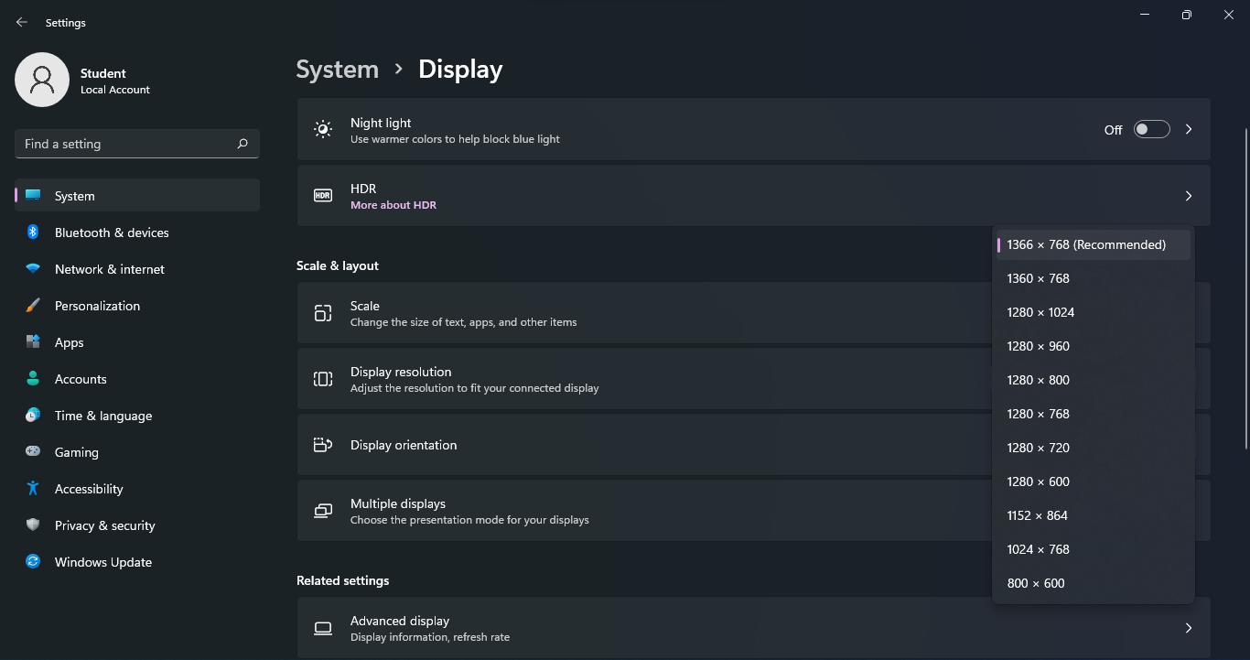

- Types of browsers in windows:
There are many types of browsers available for windows. Some of them include:
- Microsoft Edge (the default)
- Google Chrome
- Mozilla Firefox
- Opera GX
- Brave
- Vivaldi
- Tor Browser
